Academic Year: 2026-27

Lab Sheet: Java Tutorial and Programming Practice
Module Code: CO3408 | Module Title: Advanced Software Modelling

This lab introduces you to basic Java programming practice and the use of online programming tools. If Java or a Java editor such as IntelliJ IDEA or Eclipse is not available on your computer, you can use an online Java editor/compiler to write and run your programs. For example, you can use an online Java compiler such as JDoodle – Online Java Compiler. Your tutor may demonstrate one of these tools during the lab.

By the end of this lab you will be able to:
- run a Java program using an IDE or an online editor;
- declare variables of different data types and print their values;
- write programs that make decisions using if / else;
- write programs that repeat instructions using a for loop;
- write and call methods;
- recognise and fix a simple compile-time error.

GETTING STARTED – INSTALLING THE JDK ON A UNIVERSITY COMPUTER

Java programs need the Java Development Kit (JDK) to compile and run, and an IDE such as Eclipse to edit them comfortably. Follow whichever of these applies to the computer you are using.

1. Check whether Java is already installed
- Open a command prompt or terminal.
- Type java -version and press Enter. If a version number appears (Java 17 or later is fine for this module), Java is already installed and you can go straight to step 3.
- Also try javac -version to check the compiler is installed, not just the run-time.

2. Install the JDK if it is missing
- On a University PC, open Software Center (Windows) or AppsAnywhere, search for Java JDK or IntelliJ IDEA or Eclipse or Visual Studio Code (which can install its own JDK for you), and install it. Do not download installers from the open internet on University machines: use the University’s own software catalogue.
- If neither is available or you are not able to install software, ask your tutor, or use an online editor for this session (see the note at the top of this lab) while it is arranged.
- On your own computer, download the JDK from Oracle JDK downloads or use a free build such as Eclipse Temurin. Choose the long-term support (LTS) version.

3. Open or create your project
- Open IntelliJ IDEA or Eclipse. Create a New Project (a plain Java project is fine; you do not need a build tool such as Maven or Gradle for this lab).
- Create a folder called CO3408_Labs to keep your work in, and add a new Java class called Main for each task below.
- If you are using the command line instead of an IDE, save your file as Main.java, then compile and run it with:
javac Main.java
java Main

Using a University PC? Save your work to your own storage (OneDrive, a USB drive or your personal drive), because files on lab PCs may be deleted when you log out.

If something goes wrong
Problem | What to try
java -version or javac -version is not recognised | Java is not installed, or not on the PATH. Install it through Software Center/AppsAnywhere, or ask your tutor. Meanwhile use an online editor.
The IDE cannot find a JDK | In IntelliJ, go to File > Project Structure > SDK and select or download a JDK from there.
“public class Main is public, should be declared in a file named Main.java” | Java requires the file name to match the public class name exactly, including capitalisation.
Nothing happens when you run the program | Make sure you saved the file before running, and that there are no red underlines (compile errors) in the editor.

TASK 1 – READ A JAVA TUTORIAL

Read the following introductory Java topics from a reliable Java tutorial: Java Tutorial – W3Schools.

Topic | What does it do? | Example
Variable | Stores a value | int age = 20;
Data type | Defines the type of value | int, double, String
if | Makes a decision | if (age >= 18)
Loop | Repeats instructions | for
Method | Groups reusable code | calculateTotal()

TASK 2 – RUN YOUR FIRST JAVA PROGRAM

Create the following program:
public class Main {
public static void main(String[] args) {
System.out.println("Hello CO3408 Advanced Software Modelling!");
}
}

Expected output
Hello CO3408 Advanced Software Modelling!

Question | Your Answer
What does System.out.println() do? | It prints something to the console and moves it to new line. First two output stream println prints in new line
What happens if you change the message to your own name? | It will print my own name
What happens if you remove the semicolon ;? | Program doenst compile. Semicolon ends a statement
What error message do you receive? | 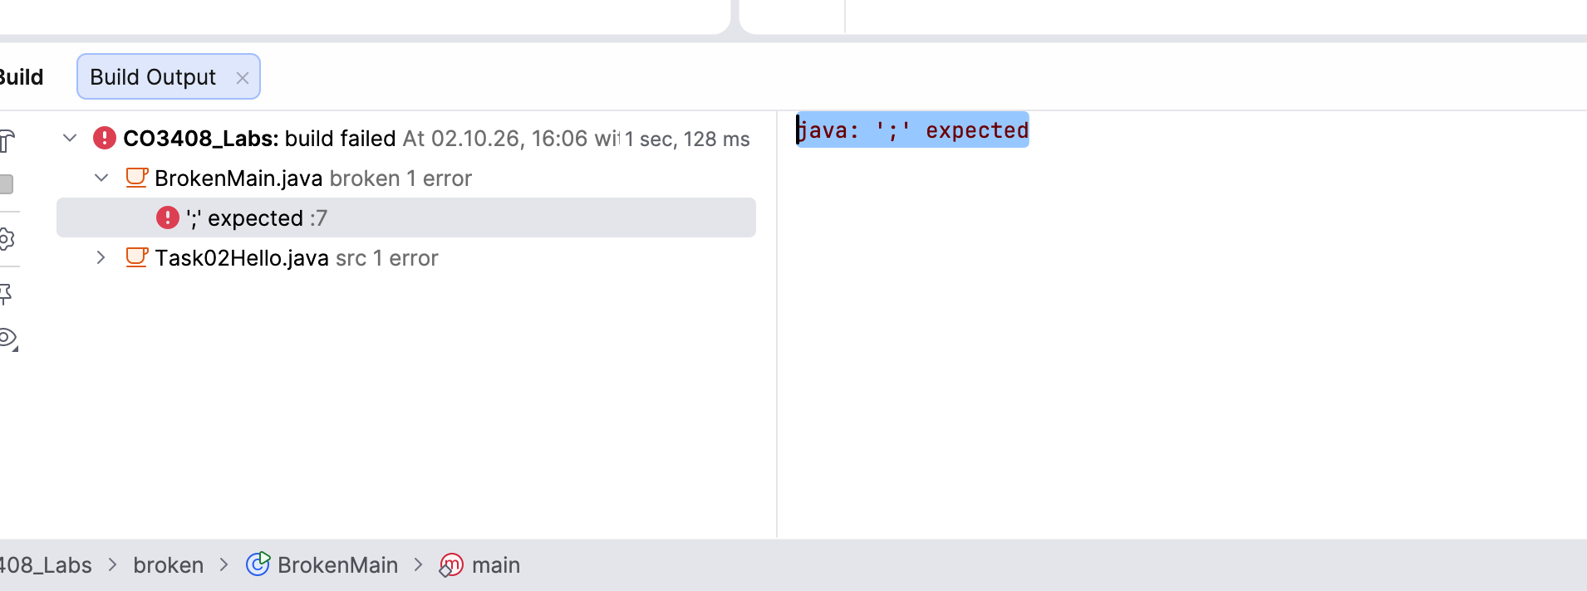

TASK 3 – VARIABLES AND OUTPUT

Run the following program:
public class Main {
public static void main(String[] args) {
String name = "Bob";
int age = 21;
double mark = 65.5;

System.out.println("Name: " + name);
System.out.println("Age: " + age);
System.out.println("Mark: " + mark);
}
}

Questions
- What data type is used for name? String
- What data type is used for age? Integer
- What data type is used for mark? Double for floating point numbers 12.5
- What happens if you change age from 21 to "21"? Code wont compile since age needs an integer not a string
- Why might different data types be required?
Correctness int cannot hold 65.5 so a mark needs a double; a name cannot be a number at all.
Meaningful operations

TASK 4 – MAKE A DECISION

Run the following program:
public class Main {
public static void main(String[] args) {
int mark = 65;

if (mark >= 40) {
System.out.println("Pass");
} else {
System.out.println("Fail");
}
}
}

Change the value of mark and run the program after each change.

Question | Your Answer
What happens when the mark is below 40? | FAIL
What happens when the mark is exactly 40? | PASS
What happens when the mark is above 40? | PASS
What would happen if you changed >= 40 to > 40? | Every mark above 40 will be a PASS

TASK 5 – REPETITION USING A LOOP

Run the following program:
public class Main {
public static void main(String[] args) {
for (int i = 1; i <= 5; i++) {
System.out.println("Iteration: " + i);
}
}
}

Change the program so that it prints the numbers from 1 to 10.

Question | Your Answer
How many times does the loop execute? | 5
What is the purpose of i++? | after each pass it adds 1 to i. Without it i would stay at 1, and the loop would run forever
What happens if you change i <= 5 to i <= 10? | Loop will run until i reaches 10

TASK 6 – METHODS

Read about Java methods and run the following example:
public class Main {
public static void main(String[] args) {
greet();
greet();
}

static void greet() {
System.out.println("Welcome to CO3408!");
}
}

Questions
- How many times is the greet() method called? twice
- How many times is the message printed? twice
Why might methods be useful in software development?
So you dont have to duplicate code one method is defined to do something and called from other methods. Therefore fixing errors also becomes easier. Code is easier to understand like get and set you know exactly what that means. For testing its also easier since a small method can be tested on its own (self-contained method)
- What would happen if you changed the message inside the method? The greet is called the changed message is printed

TASK 7 – SMALL PROGRAMMING CHALLENGE

Create a Java program that stores:
- a student’s name;
- three marks.

The program should calculate the average mark and display it. For example:
Student: Ahmed
Mark 1: 60
Mark 2: 70
Mark 3: 80
Average: 70.0

TASK 8 – WHAT HAPPENS WHEN CODE GOES WRONG?

Programming involves making mistakes and fixing them. Deliberately introduce one error into your program. For example, change:
System.out.println("Hello");

to:
System.out.println("Hello")

Run the program.

Question | Your Answer
What error did you receive? | 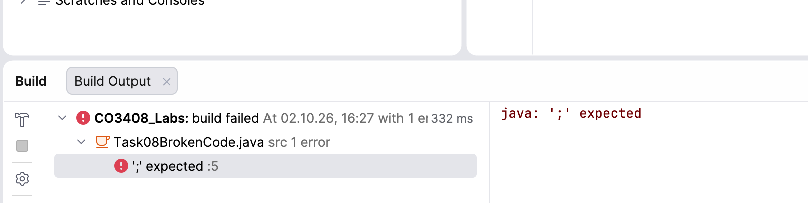
Which line caused the error? | Line 5 (:5)
What did you change to fix it? | Add a semicolon
Did the program run successfully after the correction? | yes

Important. Error messages are useful. Read them carefully rather than immediately asking someone else to fix the problem.

GROUP DISCUSSION – SOFTWARE DEVELOPMENT PRACTICE

Work in a small group of 4–5 students and discuss the following questions.

Question 1. Why might a developer use an online editor instead of installing a local development environment?
Question 2. What are the advantages of using a local IDE such as IntelliJ IDEA?
Question 3. What are the limitations of an online compiler?
Question 4. Why is it useful to run and test small pieces of code before developing a larger system?

